In this tutorial we learn how machine learning is used in many key fields and industries.

For example in the Health care industry, the data scientist use machine learning to predict whether a human cell that is believed to be at risk of developing cancer is either benign or malignant.

You also learn about the importance of decision trees, and how building a good decision tree with historical data that help doctors to prescribe the proper medicine for each of their patients.

You will learn how bankers making the decision on whether to approve loan applications.

You will learn how to use machine learning to do bank customer segmentation.

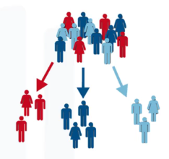

You will see how machine learning helps websites such as YouTube, Amazon or Netflix develop recommendations to their customers about various products or services such as which movie they might be interested to watch or which book to buy.

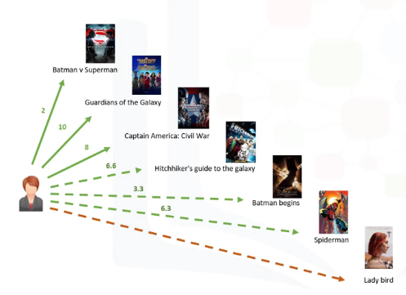

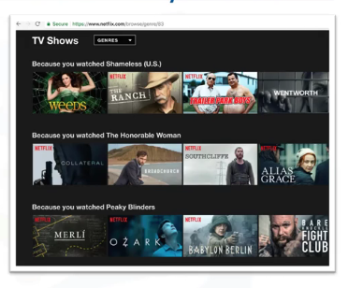

We can even predict the CO2 emission of the car that not have been released yet and we will see how telecommunication industries can predict the customer churn.

There is so much you can do with machine learning.

At the end of this session you will have knowledge in the below concepts:

* Regression
* Classification
* Clustering
* Scikit Learn
* Scipy

So far we have seen some of the real time application of machine learning, now let’s jump into **what** is machine learning?

Now, let me give a formal definition of machine learning.

Machine learning is the subfield of computer science that gives "**computers the ability to learn without being explicitly programmed.**”

Machine Learning impacts society in a very influential way.

Here are some real-life examples:

* First, how do you think Netflix and Amazon recommend videos, movies, and TV shows to its users?
* They use Machine Learning to produce suggestions that you might enjoy! .This is similar to how your friends might recommend a television show to you, based on their knowledge of the types of shows you like to watch.
* How do you think banks make a decision when approving a loan application?
* They use machine learning to predict the probability of default for each applicant, and then approve or refuse the loan application based on that probability
* Telecommunication companies use their customers’ demographic data to segment them, or predict if they will unsubscribe from their company the next month.
* There are many other applications of machine learning that we see every day in our daily life, such as Chabot’s, logging into our phones or even computer games using face recognition. Each of these use different machine learning techniques and algorithms.

By this point, I’m quite sure this question has crossed your mind, “**What is the difference between** these buzzwords that we keep hearing these days, such as **Artificial intelligence (or AI), Machine Learning and Deep Learning**?”

Well, let me explain what is different between them.

AI

In brief, AI tries to make computers intelligent in order to mimic the

Cognitive functions of humans. So, Artificial Intelligence is a general

Field with a broad scope including: Computer Vision, Language

Processing, Creativity, And Summarization.

Machine Learning is the branch of AI that covers the statistical

Part of artificial Intelligence. It teaches the computer to solve

Problems by looking at hundreds or thousands of examples,

Learning from them, and then using that experience to solve

The same problem in new situations.

Deep Learning is a very special field of Machine Learning

Where computers can actually learn and make intelligent

Decisions on their own. Deep learning involves a deeper level

Of automation in comparison with most machine learning

Algorithms.